

*Volume 1 No 1*

*MAY 15, 2019*



*LNG fleet expansion set to continue*

*COSCO Shipping Ports’ Profit*

*Drops as Volumes Rise*

While the oil tanker market (despite an increase in demolition) continued to be burdened by overcapacity and low freight rates, the LNG tanker market is booming driven by increased LNG demand from Asian economies (in particular China, Japan, South Korea and India). The high number of new LNG carrier orders and deliveries in 2018 reflects this.

[more>>>>](https://www.isl.org/en/news/lng-fleet-expansion-set-to-continue)

Despite a rise in volumes and revenue, the net profit of Hong Kong-based port operator COSCO Shipping Ports plunged in the first quarter of 2019.

For the three months ended March 31, the company’s net profit was at USD 49.9 million, representing a drop of 27.9 percent compared to the same period a year earlier.

[more>>>>](http://en.sisi-smu.org/index.php?c=article&id=17825)

*Satisfaction survey in container transport*

*Crude Oil Trade: Large ships still struggling in the freight market*

London, UK, and Brussels, Belgium, 8 April 2019: The level of satisfaction concerning container carriers among exporters, importers, and freight forwarders falls marginally, according to the third annual shipper satisfaction survey of Drewry and the European Shippers’ Council (ESC).

[more>>>>](https://www.drewry.co.uk/news/satisfaction-survey-in-container-transport-shippers-dissatisfied-with-clarity-of-surcharges-and-transit-times)

With the freight market going through a quiet period, it came as no surprise that there has been no significant change in the freight market over the last week, with earnings for VLCCs remaining flat. MEG to China stands close to WS 37, with a TCE still below USD 7,000 per day.

[more>>>>](https://ihsmarkit.com/research-analysis/crude-oil-trade-large-ships-still-struggling-in-freight-market.html)

*Jason Goodhand joins DNV GL as business lead for energy storage*

*Transport in 2040:*

*how automation and technology*

*will impact the future of work*

Grid-connected energy storage plays a critical role in the transition to a cleaner, greener energy supply, allowing energy systems with high proportions of variable renewable energy sources such as wind and solar to meet demand reliably at all times.

[more>>>>](https://www.dnvgl.com/news/jason-goodhand-joins-dnv-gl-as-business-lead-for-energy-storage-148102)

On 15 January the International Transport Workers’ Federation (ITF) and the World Maritime University (WMU) launched a flagship report entitled: “Transport 2040: Automation Technology Employment - the Future of Work”.

[more>>>>](https://www.wmu.se/news/transport-2040-how-automation-and-technology-will-impact-future-work)



*Trade Policy Insights: EU Agriculture-New US Trade War?*

*Proposed US auto tariffs would have*

*a significant negative impact on*

*key East-West trade routes*

London, UK, 10 April 2019 – Key US ports, leading global container lines and specialist car carriers will all be adversely impacted should the proposed US auto tariffs be implemented in the second quarter of 2019, according to an impact analysis published by global shipping consultancy Drewry.

The study explored the impact of three different tariff scenarios; a low-intensity scenario with 5% tariffs imposed on all US imports of finished vehicles and auto parts, a medium-intensity scenario at 15% and a high-intensity scenario with 25% tariffs imposed.

[more>>>>](https://www.drewry.co.uk/news/proposed-us-auto-tariffs-would-have-a-significant-negative-impact-on-key-east-west-trade-routes)

*[DP vessel detect and handle a netstorm](https://www.drewry.co.uk/news/proposed-us-auto-tariffs-would-have-a-significant-negative-impact-on-key-east-west-trade-routes)*

*[To Keep or Abolish Anti-Trust Immunity Is About the Fate of Liners](https://www.drewry.co.uk/news/proposed-us-auto-tariffs-would-have-a-significant-negative-impact-on-key-east-west-trade-routes)*

A netstorm is simply an excessive amount of traffic, or more specifically, a flood of packets on the network. In a control system network scenario, the vastly increased number of packets can cause controllers to become overloaded, unable to handle their normal tasks – such as controlling a thruster (DP), monitoring shutdown conditions (ESD), or providing switchboard protection (PMS). Valid packets may never reach their intended destination.

Imagine a postal worker, on a typical day, manually sorting parcels on a narrow conveyor belt for delivery.

[more>>>>](https://blogs.dnvgl.com/oilgas/safety/can-your-dp-vessel-detect-and-handle-a-netstorm/)

Key points:

* In 2018, the US deficit reached 879 billion USD, the largest in over 20 years. The US has to find alternative markets for agricultural products as there is no longer demand in China.
* On April 15, the EU and US agreed to launch trade talks, aiming to be finalized this year.
* The US wants the EU to open the market for agriculture products and threaten with 25% tariffs on cars.
* The EU agreed to review non-tariff barriers and discuss tariffs on industrial goods...

[more>>>>](https://ihsmarkit.com/research-analysis/eu-agriculture-new-us-trade-war.html?ite=971397&ito=1276&itq=430a146e-9ae6-489e-8420-9c72a0927feb&itx%5Bidio%5D=21965421)

The European Commission recently launched a study on whether to extend the Consortia Block Exemption Regulation (BER) for liners for another five years. Market players in the industry can share their views on whether they support or oppose the extension with the European Commission before the end of December.

As the exemption explicitly stipulates that vessels can in the meantime enter into space sharing agreements, liners are calling the implementation of this regulation . However, there are two competing views on keeping or abolishing the regulation,…

[more>>>>](http://www.csapchina.com/)

C



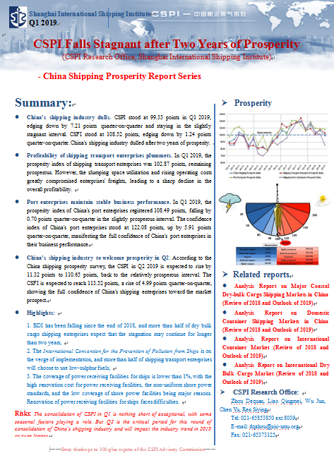

hina Shipping Prosperity Index

**Overview:**

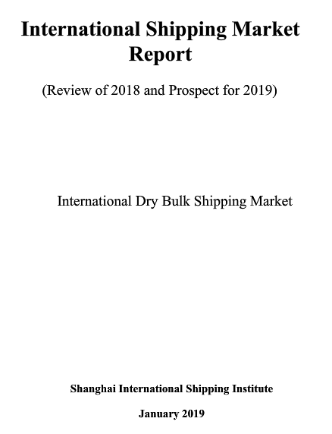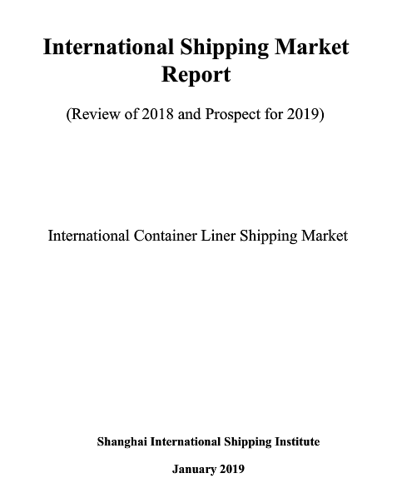Through an established regular survey system of more than 200 typical shipping companies and data analysis of relevant economic indicators, China Shipping Prosperity Report, based on China Shipping Prosperity Index (CSPI), monitors and forecasts the development and trend of domestic shipping industry with bonus analysis on hot shipping related issues in China. CSPI has become an important barometer of China’s shipping industry regarded as the PMI of China’s shipping industry.opportunities."

**Overview:**

International Container Liner Shipping Market Analysis Report traces international and domestic economy and trade, presents comprehensive update on global container fleet, gives in-depth analysis on the latest industry policy and market variations.

(Dry Bulk)

International Dry Bulk Shipping Market Analysis Report traces the status quo of dry cargo supply and demand, presents comprehensive update on global dry bulk fleet, and gives in-depth analysis on the latest industry policy and market variations.

(Container Liner)

I

nternational Shipping Market Report

[More>>>](http://en.sisi-smu.org/index.php?c=article&id=17772)

[More>>>](http://en.sisi-smu.org/index.php?c=article&a=type&tid=34)